ML-based Cyberattack Detection in Industrial Control Systems (ICS)

Feature Selection

Attack Description

The objective of the considered attacks is to disrupt, manipulate, or observe the control process while maintaining varying degrees of stealth. There are four main attacks in ICS frameworks: Reconnaissance, Denial-of-Service (DoS), Man-in-the-Middle (MITM), and Replay attacks [1]. Figure 1 shows how an attacker can penetrate an ICS infrastructure and, once inside the control network, deploy tools to carry out these four types of attacks.

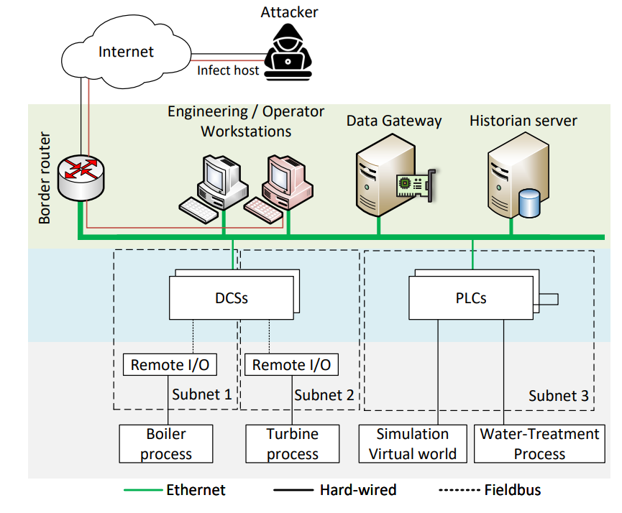
Figure 1. ICS infrastructure with an attacker compromising a host.

Reconnaissance Attack
The reconnaissance attack aims to gather information about the ICS network, devices, and communication patterns without immediately disrupting operations. An adversary passively or actively monitors network traffic between PLCs, HMIs, and sensors to identify IP addresses, protocols, register mappings, and command sequences used in the bottle-filling process. This information can later be used to enable more targeted attacks, such as command injection or traffic manipulation.
In this scenario, reconnaissance primarily manifests as abnormal scanning behavior or increased network observation activity, while the physical process continues to operate normally.

Denial-of-Service (DoS) Attack
The DoS attack targets the availability of the control system by overwhelming PLCs or network links with excessive traffic or malformed requests. The attacker’s objective is to delay or block legitimate control commands and sensor updates, causing degraded or halted system operation.
DoS attack may result in delayed PLC responses, missed control cycles, or stalled conveyors and valve operations. This attack directly impacts both the cyber layer (network congestion, packet loss) and the physical process (timing violations and control instability).

Man-in-the-Middle (MITM) Attack
In the MITM attack, the adversary positions themselves between communicating ICS components, such as between an HMI and a PLC or between sensors and PLCs. The attacker intercepts, modifies, or selectively forwards control commands and sensor readings while maintaining the appearance of legitimate communication to both endpoints.
The objective of this attack is to manipulate the physical process—such as altering reported tank levels or valve states—without triggering immediate alarms. In the bottle-filling system, this may cause overfilling, underfilling, or unsafe operating conditions while the HMI displays falsified normal values.

Replay Attack
The replay attack involves capturing valid control or sensor messages during normal operation and retransmitting them later. By replaying previously observed legitimate traffic, the attacker can deceive PLCs or HMIs into acting on outdated or incorrect system states.
A replay attacks may cause the control logic to operate on stale sensor values, leading to mismatches between the actual physical state and the perceived state of the system. This attack is particularly dangerous in ICS environments because replayed traffic is syntactically correct and difficult to distinguish from normal operation without temporal or behavioral analysis.

Observable Indicators
Observable indicators are measurable deviations in network traffic, system behavior, or physical process data that occur during cyber attacks on the industrial control system. Indicators can be observed through synchronized PCAP network traces, PLC and HMI system logs, and physical sensor readings, enabling correlation between cyber-layer activity and physical process behavior.
- Reconnaissance Attack:
Characterized by abnormal network probing activity such as increased connection attempts, port scans, or unusual register queries in PCAP traces while the physical process continues to operate normally.
- Denial-of-Service (DoS) Attack:
Evidenced by sudden spikes in traffic volume, packet loss, or retransmissions accompanied by PLC communication timeouts and resulting physical process disruptions such as delayed or unstable actuator behavior.
- Man-in-the-Middle (MITM) Attack:
Indicated by inconsistencies between network traffic content, PLC logs, and physical sensor readings, where manipulated control or sensor values cause abnormal physical behavior while the HMI displays nominal states.
- Replay Attack:
Observed through temporally inconsistent yet syntactically valid network traffic, including repeated packet payloads or command sequences that cause the control system to act on stale sensor data.

Feature Selection and Rationale
Design goals: Features must be extractable from PCAP using Zeek, be computationally lightweight, and sensitive to abrupt and low-rate anomalies. Only the first packets within a fixed flow window are used to minimize detection latency.
Baseline statistical and timing features (computed per flow):
- Minimum sensor value: detects lower-bound violations from manipulated or stale data.
- Maximum sensor value: detects upper-bound violations and abnormal peaks.
- Mean sensor value: highlights sustained shifts in operating point.
- Sensor value range: captures short-term variability and injected fluctuations.
- Sensor value slope: measures rate-of-change to detect unrealistic dynamics.
- Minimum inter-arrival time (min_iat): identifies high-frequency packets from scans or floods.
- Maximum inter-arrival time (max_iat): identifies delayed or missing updates (DoS effects).
- Mean inter-arrival time (mean_iat): characterizes timing regularity and replay anomalies.

Temporal Signal Processing (EWMA & CUSUM)
Purpose: EWMA and CUSUM increase sensitivity to slow, persistent deviations that may evade simple statistical checks, and they remain computationally inexpensive for online monitoring. Both are computed from Zeek-extracted sensor values and timestamps.

EWMA (Exponentially Weighted Moving Average):
z_t = α x_t + (1 − α) z_{t−1}
where x_t is the sensor value at time t and α ∈ (0,1] is the smoothing factor controlling responsiveness.
Rationale: EWMA smooths high-frequency noise while preserving gradual shifts; choosing α balances detection delay against noise suppression (small α → smoother, larger α → more responsive) [2].

CUSUM (Cumulative Sum):
C_t^+ = max(0, C_{t−1}^+ + (x_t − μ_0 − k))
C_t^- = min(0, C_{t−1}^- + (x_t − μ_0 + k))
where x_t is the sensor value at time t and α ∈ (0,1] is the smoothing factor controlling responsiveness [3].
Rationale: CUSUM accumulates small deviations to detect persistent drifts; it is effective against low-amplitude, long-duration attacks (stealthy MITM or replay) that do not produce large instantaneous residuals.

Potential dataset(s)
Dataset: ICS Dataset (Sudyana, v1, released September 20, 2025) [4]: https://zenodo.org/records/17165850
The experiments in this work use the ICS Dataset was generated to support anomaly detection research in Cyber-Physical Systems (CPS). The dataset is produced using an extended version of the ICSSIM emulator that models an industrial bottle-filling process consisting of two PLCs, two HMIs, a water tank, valves, and conveyor belts, closely reflecting real-world industrial control system architectures.

Operational scenarios in the dataset are divided into normal operation, system faults, and cyber attacks. Normal operation serves as a baseline for learning standard system behavior, while five injected fault types, such as sensor drift, tank leak, PLC overheating delay, valve malfunction, and memory corruption, allow evaluation of robustness against non-malicious anomalies. The cyber attack scenarios include four representative attacks mapped to the MITRE ATT&CK for ICS framework: Reconnaissance, Denial-of-Service (T0806), Man-in-the-Middle, and Replay.

References:
[1] MITRE Corporation. Tactics – Industrial Control Systems. MITRE ATT&CK, https://attack.mitre.org/tactics/ics/. Accessed 31 Jan. 2026.
[2] Zhang, Minghu, Xin Li, and Lili Wang. "An adaptive outlier detection and processing approach towards time series sensor data." Ieee Access 7 (2019): 175192-175212.
[3] Murguia, Carlos, and Justin Ruths. "Characterization of a cusum model-based sensor attack detector." 2016 IEEE 55th Conference on Decision and Control (CDC). IEEE, 2016.
[4] Sudyana, Didik. ICS Dataset. Zenodo, Sept. 2025, https://doi.org/10.5281/zenodo.17165850.

